PRACTICAL 02: Career-Oriented Presentation

Aim

To create a career presentation using slides, transitions, and animations.

Objectives
•To design a multi-slide professional presentation
•To apply transitions and animations

Materials Required
•PowerPoint or Google Slides

Procedure

1. Open a blank presentation
Launch PowerPoint/Google Slides and select the option to create a new blank presentation.
This opens a fresh workspace where you will design your slides.
2. Create a title slide
Insert a title slide layout and add the presentation title along with your name or subtitle.
Ensure the title is clear, readable, and visually centered on the slide.
3. Add minimum 7 slides
Use the “New Slide” option to insert at least seven additional slides with appropriate layouts.
Each slide should focus on a single topic or idea for clarity.
4. Insert images, icons, and bullet points
Add relevant images and icons to visually support your content.
Use bullet points to present information in a structured and easy-to-read format.
5. Apply a theme
Choose a professional theme from the design options available in the software.
The theme will automatically set consistent fonts, colors, and backgrounds.
6. Add transitions and animations
Apply slide transitions for smooth movement between slides.
Add animations to text or images to enhance the presentation without overusing effects.

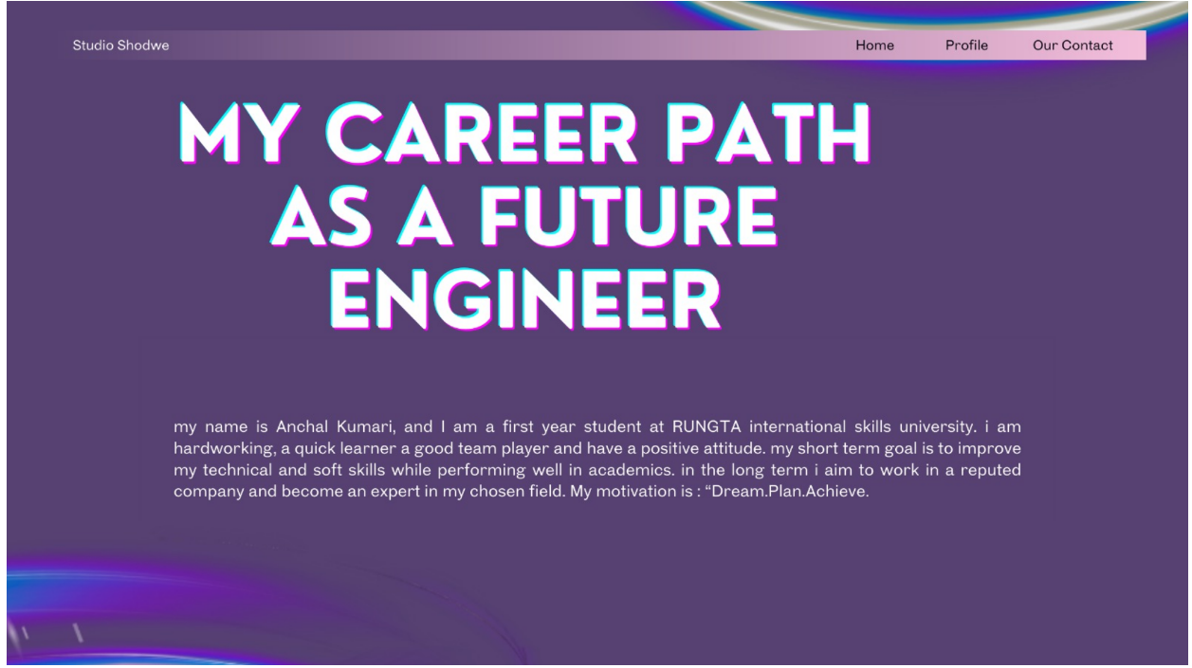
Output:
